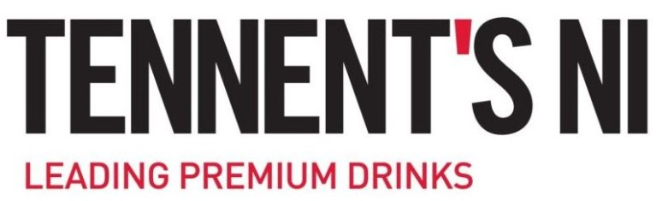

Business Development Wine Manager

Bulmers Ireland is part of C&C Group plc, a large FMCG company headquartered in Ireland. The Group operates in the alcoholic drinks and soft drinks industries and has a portfolio of industry-leading brands such as Bulmers, Magners, Tennent’s, Tipperary Water and Finches. We have leading category positions in Ireland and the UK and exports to 50 other countries globally. Bibendum Ireland is the groups wine business for the Island of Ireland and has been in rapid growth over the last number of years. It is due to this growth that we need to expand our team further.

What you’ll do
The Business Development Wine Manager will be directly responsible for:
- Contribution to the development of Bibendum ROI commercial sales strategy to maintain and develop on-trade driven opportunities and increase profitability for our wide portfolio.
- Identify sales volume/value growth opportunities through the analysis of customer and market performance information/data.
- Work closely with the Bulmers sales team in order to optimise our sales and share performance.
- Depending on outlet - develop wine & commercial proposals for the rep based on their customer needs
- Wine Tastings with prospect & current accounts
- Supporting the on-trade reps with staff training
- Supporting the on-trade reps with menu templates that they can share with their customers for menu & POS development.
- Supplier Trade Visits – supporting our on trade customers & on trade reps by inviting their customers to trade & consumer tastings / events

What you’ll need
- You’ll need a full Driving License with a demonstrable passion and attitude for sales. Experience of on trade wine portfolio selling & Level 2 WSET would be ideal.

- You will have outstanding communication and influence skills with the ability to quickly build rapport. You’ll be able to demonstrate a commercial acumen with an ability to negotiate.
- You’ll have a natural entrepreneurial spirit with the ability to pipeline activity plus identify and follow up on leads.
- You will have experience in supporting on trade sales teams with your expertise in wine knowledge, representing a leading portfolio of internationally recognised wines from around the globe.
- You will have the ability to present wines to knowledgeable customers assessing their requirements and delivering commercial success both for your customer and Bibendum Ireland.
- You will have experience in hosting wine tasting nights both at customer account level and trade events.
- Be fully experienced in using Microsoft Office systems - Excel, Powerpoint
- In return we offer a competitive basic salary with a clear and achievable bi-annual bonus. In addition, you will receive a fully expensed company car, pension, laptop, and mobile phone.

Sound interesting?
Send us a CV that demonstrates your skills, and we’ll come back to you ASAP!
Bulmers Ireland is part of C&C Group (and inclusive companies) we do not accept unsolicited CV’s from recruiters or employment agencies in response to any of our roles – we will not consider or agree to payment of any referral compensation or recruiter fee relating to unsolicited CVs including those submitted to hiring managers. C&C Group explicitly reserves the right to hire those candidate(s) without any financial obligation to the recruiter or agency.

