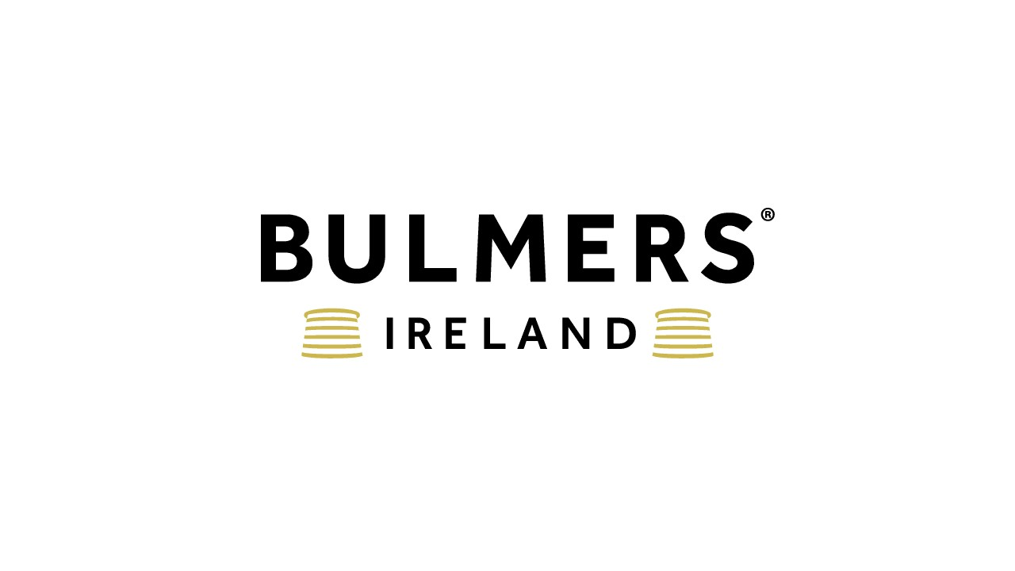

Business Development Manager

C&C Group plc is a large FMCG company headquartered in Ireland. The Group operates in the alcoholic drinks and soft drinks industries and has a portfolio of industry-leading brands such as Bulmers, Magners, Tennent’s, Tipperary Water and Finches. We have leading category positions in Ireland and the UK and exports to 50 other countries globally.

What’s Involved
- To lead new business development of a prioritised Bulmers & Craft portfolio within the wider IOI portfolio of brands by leveraging off the existing customer base and enhancing via new business wins.
- The Business Development Manager will work to improve the organisation’s market position and achieve financial growth.
- This person builds key customer relationships, identifies business opportunities, negotiates and closes business deals and maintains extensive knowledge of current market conditions.

What you’ll do
- Prospect for potential new clients and turn this into increased business.
- Cold call as appropriate within your geographic area to ensure a robust pipeline of opportunities.
- Meet potential clients by growing, maintaining, and leveraging your network.
- Responsibility for achievement of sales and new business wins in outlet within your geographical region.
- Achieving KPIs across the portfolio of our Brand led business both with current customers and new customers.
- Responsible for transferring orders to relevant wholesale rep, Gleesons or other.
- Manage and maintain successful customer relationships towards high levels of customer advocacy.
- Identify opportunities to increase volume and margin sales for your clients, particularly in line with key events in the geographical region.
- Submit weekly progress reports and ensure data is accurate. Ensure that data is accurately entered and managed within the company’s CRM or other sales management system.
- Track and record activity on accounts and help to close deals to meet these targets.
- Ensure that the company is represented in the best light.
- Present business development training and mentoring to business developers and other internal staff.

What you’ll need
- Excellent commercial acumen and experience of brand portfolio selling. Sales experience in a highly competitive environment.
- Ability to influence, negotiate and build strong working relationships with a friendly disposition and positive outlook.
- Strong sense of urgency to respond to customer needs, and ability to work on own initiative together with plenty of drive and ambition
- Demonstrated drive for results and overachievement across key measurable areas, ability to work on own initiative and proactively effect change to improve area performance.
- Excellent communication skills and an ability to plan organize and manage time effectively.
- Selling and negotiation skills.
- Strong IT and numerical skills.
- Full and clean driving license.
- There will be a requirement to spend time in trade on a regular basis.

Sound interesting?
Send us a CV that demonstrates your skills, and we’ll come back to you ASAP!
C&C Group (and inclusive companies) do not accept unsolicited CV’s from recruiters or employment agencies in response to any of our roles – we will not consider or agree to payment of any referral compensation or recruiter fee relating to unsolicited CVs including those submitted to hiring managers. C&C Group explicitly reserves the right to hire those candidate(s) without any financial obligation to the recruiter or agency.

