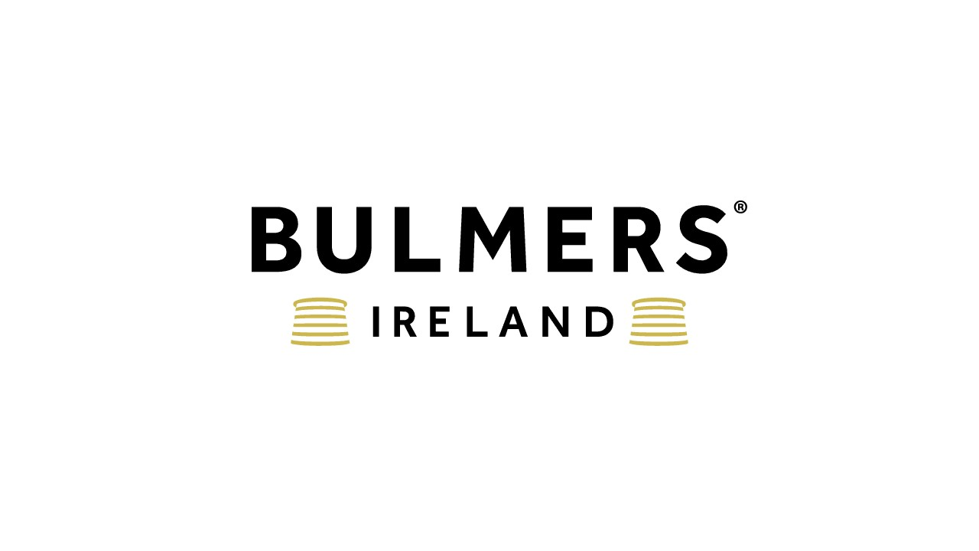
Truck Driver
Dublin- €16 per hour
C&C Group plc is a large FMCG company headquartered in Ireland. The Group operates in the alcoholic drinks and soft drinks industries and has a portfolio of industry-leading brands such as Bulmers, Magners, Tennent’s, Tipperary Water and Finches. We have leading category positions in Ireland and the UK and exports to 50 other countries globally.

We are looking for a Truck Driver to join our Distribution team in our Dublin Depot to perform several multi-drop deliveries to our customers.

What’s Involved?
- Working in a safe manner as part of our Distribution Team
- Responsible for delivering our products to our customers daily
- Multi drop delivery model
- Flexibility & work to accommodate customers delivery requirements
- Yard work supporting the depot team during quieter periods
- Ensure all invoicing & EPOD transactions are correct with delivery schedule.
- Complete vehicle pre use checks, ensuring that all documents is accurately completed
- Legally compliant with working time directive and EU driving hours legislation

What you’ll need?
- Full clean Rigid Truck C Licence
- Consistent Positive “Can do” attitude.
- Proactive approach to delivering our promise to the customer
- Previous experience delivering to end customers
- Proven ability to work within a team and be a valuable team member.

Sound interesting?
Send us a CV that demonstrates your skills, and we’ll come back to you ASAP!
C&C Group (and inclusive companies) do not accept unsolicited CV’s from recruiters or employment agencies in response to any of our roles – we will not consider or agree to payment of any referral compensation or recruiter fee relating to unsolicited CVs including those submitted to hiring managers. C&C Group explicitly reserves the right to hire those candidate(s) without any financial obligation to the recruiter or agency.

