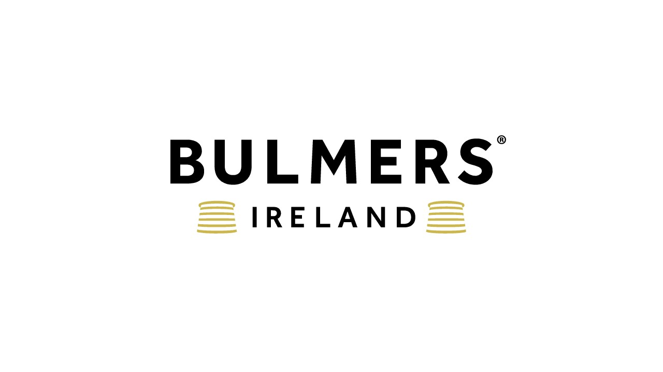
Warehouse Operative
C&C Group plc is a large FMCG company headquartered in Ireland. The Group operates in the alcoholic drinks and soft drinks industries and has a portfolio of industry-leading brands such as Bulmers, Magners, Tennent’s, Tipperary Water and Finches. We have leading category positions in Ireland and the UK and exports to 50 other countries globally.

We are looking for a Warehouse Operative to join our Distribution team to ensure that all aspects of the Warehouse Operation are performed efficiently

What’s Involved?
- Goods intake and dispatch, checking for accuracy and quality and highlighting any issues.
- Record goods receipt and returns information accurately.
- Picking product using the Voice System and loading and unloading of trucks and trailers.
- Ensure stock is rotated and used on FIFO basis.
- Maintain the warehouse areas to a high standard.
- Ensure customer delivery performance targets are met.
- Ad Hoc Duties as assigned by the Depot Team Leader.

What you’ll need?
- Experience in goods receipt and distribution.
- Good understanding of Store management processes and systems, Stock take & Stock rotation.
- Experience in Voice/Order picking a positive.
- Good communication skills.
- Should be flexible to work overtime
- Proven team worker with a positive attitude
- Experience in working to deadlines in a busy environment.
Sound interesting?
Send us a CV that demonstrates your skills, and we’ll come back to you ASAP!
C&C Group (and inclusive companies) do not accept unsolicited CV’s from recruiters or employment agencies in response to any of our roles – we will not consider or agree to payment of any referral compensation or recruiter fee relating to unsolicited CVs including those submitted to hiring managers. C&C Group explicitly reserves the right to hire those candidate(s) without any financial obligation to the recruiter or agency.

